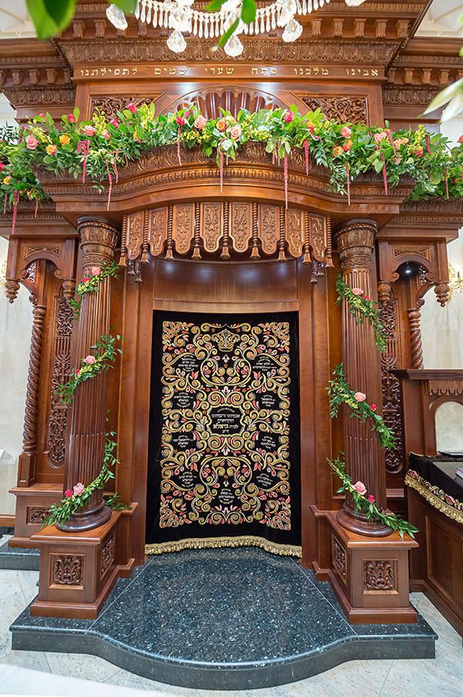
BS"D
Thank You, Hashem, for bestowing upon me
this very special opportunity
of glorifying Your House.

Thank you to the Heiligeh Rabinowitz Family
and Stamford Hill Kehilla, for allowing me
your Beis Midrash to enhance.

The Biala-Peshischa Rebbes, throughout 9 Doros
all the way back to the Yehudi HaKudosh-
To honor I have the chance.

Thank you, Mr. Schlesinger, for inviting me
to this epic project, and thank you for your keen
designer eye and suggestions.

And Mr. Micha Oberman who from Lavi did soar
to the Chanikas Habayis, and brought parochets- four,
we must not forget to mention.

Embroidery and sewing staff- so devoted and loyal
You worked days and nights; weeks and months you toiled
To ensure perfection.

Last, but not least, I owe the biggest vort
to my husband and dear children, for all of their support.
"Sheli veshelahem, shelachem!"

Although I've been designing- worldwide, for quite a while
parochets for Yeshivos and shuls in many styles,
this parochet breaks the record.

With such numerous responses- never before have I been hit.
In 12 years of production, no parochet did emit
quite such high accord.

It must be the Rebbe's zechusim, and his sincere desire
to honor his holy relatives, that elevates this higher-
enhancing the tefillos.

Hardly a day goes by without me getting a call
ever since the parochet was installed
last year, erev Shavous.

May we all be inspired, and be mekabel the Torah
on the upcoming Yom Tov of Shavous- mitoch ahava,
with deveykus!

